**RESEARCH PROPOSAL**

**PRE_PROPOSAL**

Is a short description of a project that does not involve a binding commitment of university resources.

* Steps to follow :
  1. Write a draft title for the research proposal.

• Characteristics of a good research proposal title

* It should predict the content of the research paper.
* It should be interesting to the reader.
* It should reflect the tone of the writing.
* It should contain important keywords that will make it easier to be located during a keyword search.
  1. Write a short draft **abstract** or summary of around 300 words.
* **Abstract**
  + State the objectives upfront
  + What problem am I trying to solve?
  + Use the 6 main layers of the research onion to construct the abstract

The layers of Saunders’ research onion

The onion is made up of 6 layers, which you’ll need to peel back one at a time as you develop your research methodology:

1. [Research philosophy](https://gradcoach.com/saunders-research-onion/#1)
2. [Research approach](https://gradcoach.com/saunders-research-onion/#2)
3. [Research strategy](https://gradcoach.com/saunders-research-onion/#3)
4. [Choices](https://gradcoach.com/saunders-research-onion/#4)
5. [Time horizon](https://gradcoach.com/saunders-research-onion/#5)
6. [Techniques & procedures](https://gradcoach.com/saunders-research-onion/#6)
   1. Coin a few **keywords** to describe the research proposal.

• Key words - an initial set of words to assist with a first literature review

* 1. Construct an introduction that contains a rationale and relevant literature review.
  2. State the aim, research question, sub-questions and hypotheses/null hypotheses of the proposed research study.
  3. Outline the research method.
  4. Select the setting (context), participants, sampling method, inclusion/exclusion criteria and method of recruitment.
  5. Describe data collection instruments.
  6. Detail intended data analysis.
  7. Declare any ethical considerations and outline data protection procedures.
  8. Produce a timetable and consider potential problems that may occur.
  9. Estimate resources that may be required.
  10. List key references

**PRELIM PROPOSAL**

It is wise to spend some time on planning and crafting a preliminary research proposal before a first draft of a proposal is submitted to departmental and faculty committees.

**NOTE:**It is often useful to review certain sections of the proposal as insight into your study emerges over time. After completing the first draft go back and review the line of discussion followed to ensure that the method of data gathering, and the proposed reporting and analysis clearly match the problem statement and objectives.

**Note:** Apply the Topic, Elaboration and Relevance principle (T-E-R) to writing the narrative throughout the entire proposal

Topic – What is this about? The first thing you need to clarify in a paragraph is what it is about, its topic. The first sentence of the paragraph should therefore be a ‘topic sentence’ showing what the paragraph concerns. The topic sentence could be a statement, or it could lead up to a statement that you elaborate and argue for in the rest of the paragraph.

Elaboration – How and why in an academic text, you are expected to support and provide evidence for your statements and arguments. Evidence can be both empirical (research data, surveys, facts and verifiable statements) or theoretical. Weakly founded arguments or unsupported statements cannot be discussed, and they therefore fall under the category of speculation or guesswork. In fact, it is precisely the foundations and reasons for your arguments that should form the basis of your discussion – are they good or bad? Are there other possible explanations? One way of exploring and supporting your arguments could be to demonstrate your points by way of examples.

Relevance – What does this mean? The relevance of an argument becomes particularly visible by the use of examples. Through examples, you can demonstrate how you understand the topic under discussion in practice, and you can include nuances evoked in the reader through recognition and associations. A well-chosen example may therefore save you the trouble of much elaboration and explanation. Another way of demonstrating relevance is to draw conclusions.

**The following items must be addressed:**

**1. The background**

The background in proposal establishes the foundation or the context of the research. This has to give an overview of:

* What I am going to do?
* Who has done similar research?
* What he/she/they found?
* How I am going to do this study?
* Why this study is so unique?

Finally yet importantly, carefully selected academic papers that converse the same problem must be consulted and properly referenced.

[***Sample background***](http://thesisnotes.com/thesis-writing/sample-background-of-the-study/)

**2.** A **title**should:

Is the topic on which you are doing research or the name of the project.

* predict the content of the research paper
* indicate context(s) and constructs
* introduce the research design and methodology
* contain important keywords to make it searchable

The ***research title describes***

(a) The topic, (b) the method, (c) the sample, and (d) the results of the study.

**3. Writing the introduction**

The main purpose of the introduction is to provide the context for the research problem.Describe the research context, how your study fits into other research on the topic, and conclude with the research question. The introduction should also:

* Create reader interest in the topic
* Lay the broad foundation for the problem that leads to the study
* Place the study within the larger context of the scholarly literature, and Reach out to a specific audience. (Creswell, 1994, p. 42)

Introduce why the study is done.

***3. 1. Establish an area to research by***:

- Highlighting the importance of the topic and/or

- Making general statements about the topic and/or

- Presenting an overview on current research on the subject.

***3. 2. Identify a research niche by:***

- Opposing an existing assumption, and/or

- Revealing a gap in existing research.

***3. 3. Place your research within the research niche by:***

- Stating the intent of your study,

- Outlining the key characteristics of your study, and

- Giving a brief overview of the structure of the paper.

[***Writing the introduction***](https://advice.writing.utoronto.ca/planning/intros-and-conclusions/#:~:text=The%20introductions%20for%20most%20papers%20can%20be%20effectively,to%20the%20length%20and%20complexity%20of%20your%20paper.)

[**4. The *literature review***](http://www2.psych.utoronto.ca/users/shkim/How%20to%20Write%20a%20Research%20Proposal.pdf)

A literature review is a piece of research writing demonstrating knowledge and understanding of the literature on a specific topic placed in context.This is the most important section of any proposal. A shoddy attempt at reviewing literature leads to a poorly constructed proposal in terms of writing a problem statement, objectives, etc.

***A proper literature review***:

* Ensures that you are not "reinventing the wheel".
* Gives credits to those who have laid the groundwork for your research.
* Demonstrates your knowledge of the problem under investigation.
* Demonstrates your understanding of the theoretical and research issues related to your research question.
* Shows your ability to critically evaluate relevant literature information and to integrate and synthesise the existing literature.
* Provides new theoretical insights or develops a new model as the conceptual framework for your research.
* Convinces your reader that your proposed research will make a significant and substantial contribution to the literature (i.e., resolving an important theoretical issue or filling a major gap in the literature).

***Literature reviews often suffer from the following problems:***

* Lacking an organised structure, focus, unity and coherence
* Failing to cite and critically evaluate influential papers on the topic under investigation and to keep up with recent developments in the field
* Citing irrelevant or trivial references and depending too much on secondary sources or books

[*Student experiences*](https://ojs.lib.uwo.ca/index.php/cjsotl_rcacea/article/view/8295/8657)

[*Student difficulties*](https://www.tandfonline.com/doi/pdf/10.1080/2331186X.2020.1784620)

[*The Summary-Comparison Matrix: A Tool for Writing the Literature Review*](https://documentcloud.adobe.com/link/review?uri=urn:aaid:scds:US:0569eaad-0cc2-4579-90b0-094c90559a0e)

[*Improving the writing of literature reviews through a literature integration exercise*](https://documentcloud.adobe.com/link/review?uri=urn:aaid:scds:US:1ad4ec64-d402-4683-a6fd-76389befa1b5)

[*The art of writing literature review: What do we know and what do we need to know?*](https://documentcloud.adobe.com/link/review?uri=urn:aaid:scds:US:186605fe-e3ff-4b76-85f8-ea6c2434577e)

[*Writing the literature review for empirical papers*](https://www.scielo.br/j/prod/a/6X3VYMYLYYpNtzfjgmR5QTS/?format=pdf&lang=en)

[*Ten simple rules for writing the literature review*](https://journals.plos.org/ploscompbiol/article/file?id=10.1371/journal.pcbi.1003149&type=printable)

**5. Theory, Theoretical Framework, and Conceptual Framework**

A schema for the classification of conceptual frameworks involving reading

* **Theories** are formulated to explain, predict, and understand the whole scenario of the study and, in many cases, to challenge and extend existing knowledge.
* **Theoretical framework** simply states the theory aspect of your work, the existing, tested and viable theories backing up your current research. So to say, theoretical framework is a collection of interrelated theories which guides your research work.
* **Conceptual framework** is what informs your readers on what to expect and know from your research. It defines the relevant variables for your study and maps out how they relate to each other. A conceptual framework is constructed before collecting data and often represented in a visual format. You should construct a conceptual framework before you begin collecting data.

**Difference between a theoretical and conceptual framework**

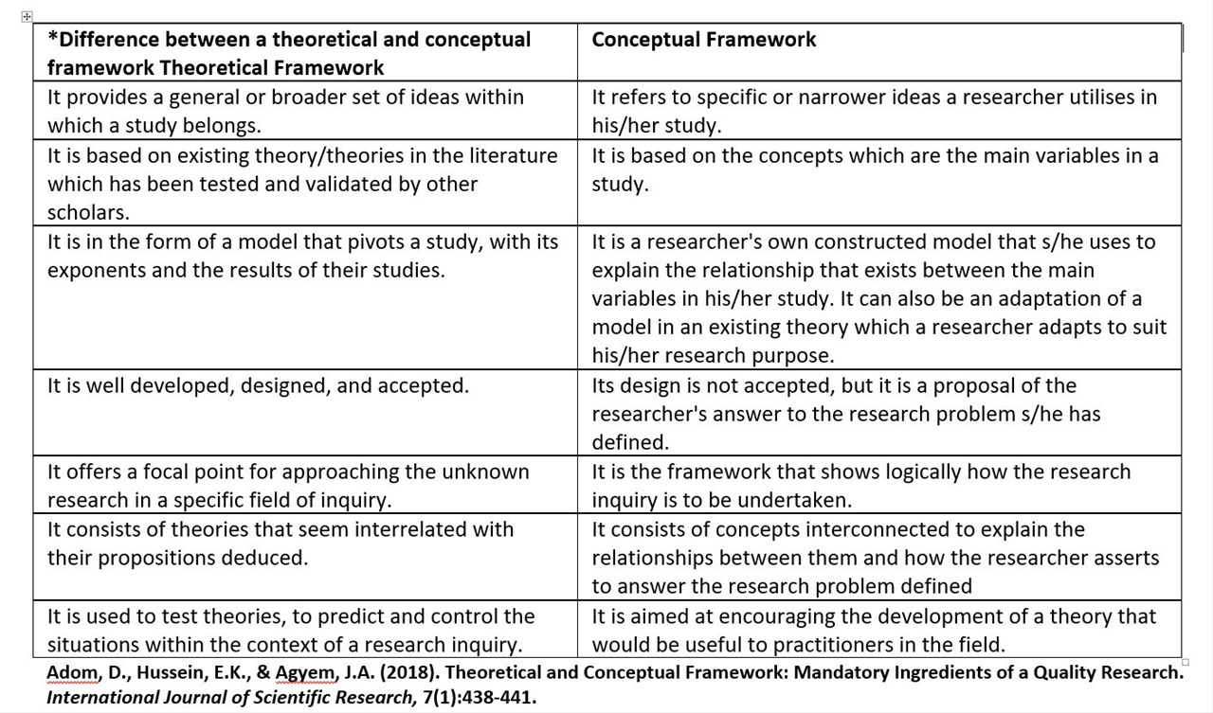

[*A Systematic Review of Lessons from the Field Theories, theoretical frameworks, and lines of inquiry may be differently handled in quantitative and qualitative endeavors.*](https://files.eric.ed.gov/fulltext/EJ1198682.pdf)

1. “In quantitative studies, one uses theory deductively and places it toward the beginning of the plan for a study. The objective is to test or verify theory. One thus begins the study advancing a theory, collects data to test it, and reflects on whether the theory was confirmed or disconfirmed by the results in the study. The theory becomes a framework for the entire study, an organizing model for the research questions or hypotheses for the data collection procedure” (Creswell, 1994, pp. 87-88).

2. In qualitative inquiry, the use of theory and of a line of inquiry depends on the nature of the investigation. In studies aiming at “grounded theory,” for example, theory and theoretical tenets emerge from findings. Much qualitative inquiry, however, also aims to test or verify theory, hence in these cases the theoretical framework, as in quantitative efforts, should be identified and discussed early on.

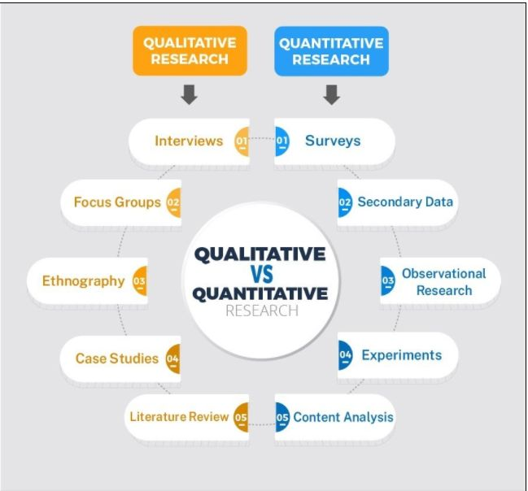

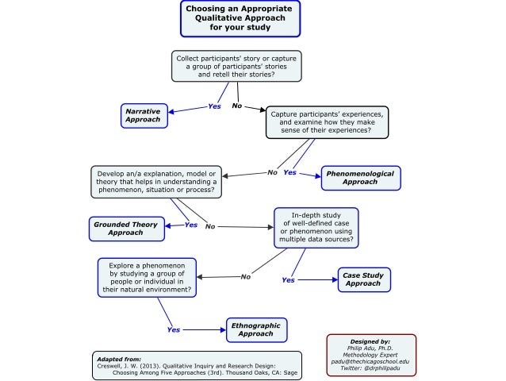

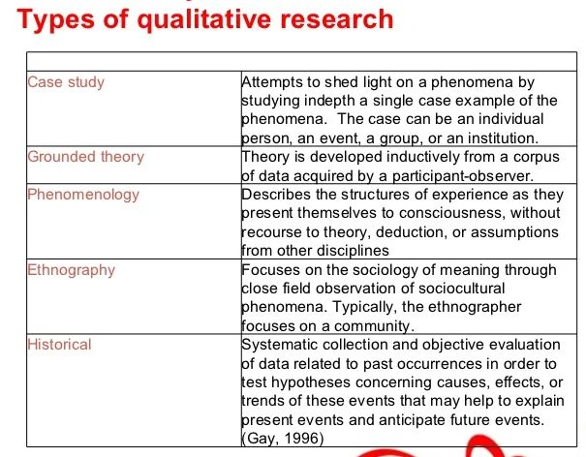

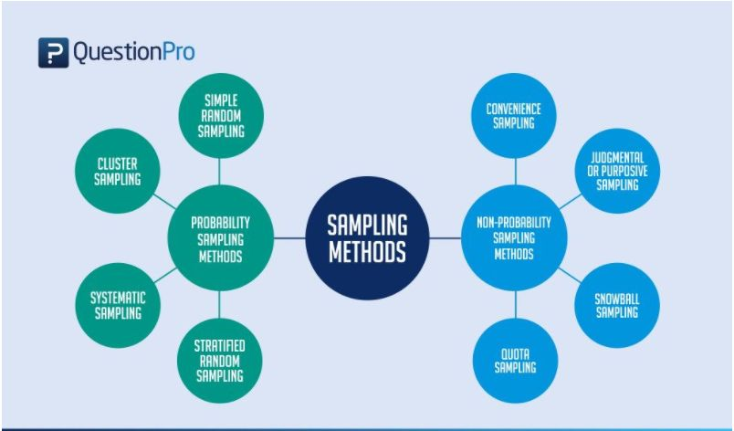

**6. Problem statement**

A problem statement in a research study is the description of an existing issue that needs to be addressed. It is a bridge between the literature review and the research methodology.It offers a concise statement about the purpose of your paper.

The purpose of a problem statement is to:

* Introduce the reader to the importance of the topic being studied. The reader is oriented to the significance of the study. - Anchor the research questions, hypotheses, or assumptions to follow. It offers a concise statement about the purpose of your paper.
* Place the topic into a particular context that defines the parameters of what is to be investigated
* Provide the framework for reporting the results and indicates what is probably necessary to conduct the study and explain how the findings will present this information.

Here are some research problem examples for you to better understand the concept.

* Practical Research Problems. To conduct practical research, you will need practical research problems that are typically identified by analysing reports, and previous research studies.
* You might also search for: Problems with performance or competence in an organisation Institutional practices that could be enhanced Problems confronted by specific groups of people within your area of study after you have identified a research problem for your project, the next step is to write a problem statement. An effective problem statement is concise.

It should:

* Put the problem in context (what do we already know?)
* Describe the precise issue that the research will address (what do we need to know?)
* Show the relevance of the problem (why do we need to know it?)
* Set the objectives of the research (what will you do to find out?)

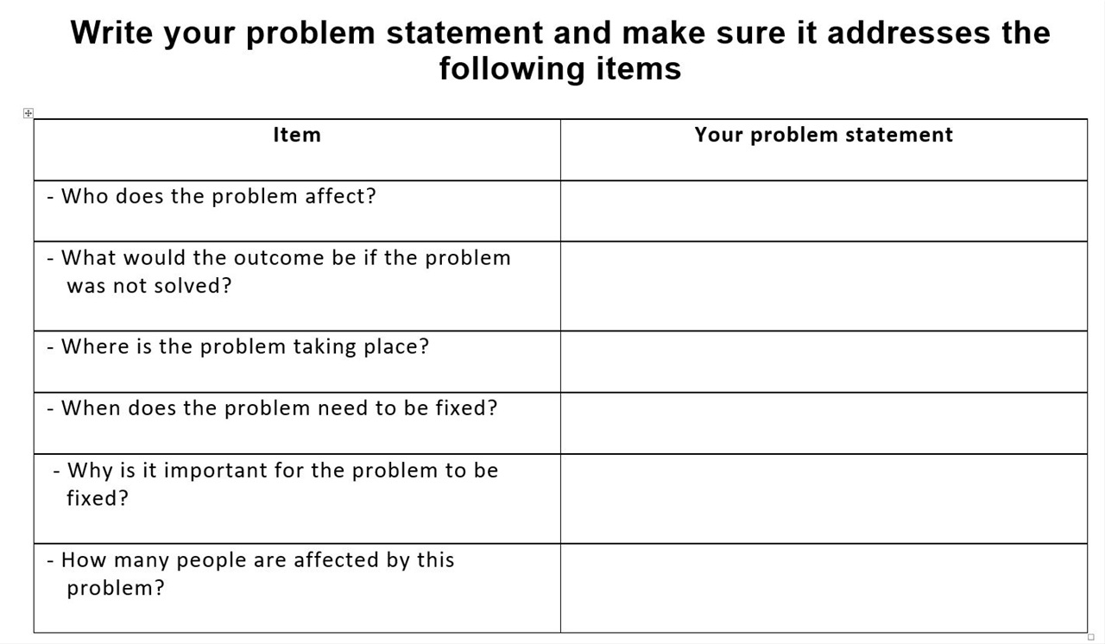

**7. Research questions and objectives**

**Research questions** are the starting point in any good research. They provide the road map to proceed and identify and focus on the research gaps.The **research objectives** are actions intended to answer the research questions in a statement form.

The research question should be framed using the PICO (Population, Intervention/Exposure, Comparator and Outcome) format and should fulfil the FINER (feasible, interesting, novel, ethically sound, and relevant) criteria for practical aspects.

How to **conduct a good research question**:

* Describe your current research question.
* State your independent variable(s) and your dependent variable(s). Remember the independent variable (IV) is what you think might be causing change in or impacting the dependent variable (DV)
* State what population is the primary focus of the research question.

Objectives should always be framed in alignment of the research question using SMART (specific, measurable, achievable, realistic and time defined) approach.

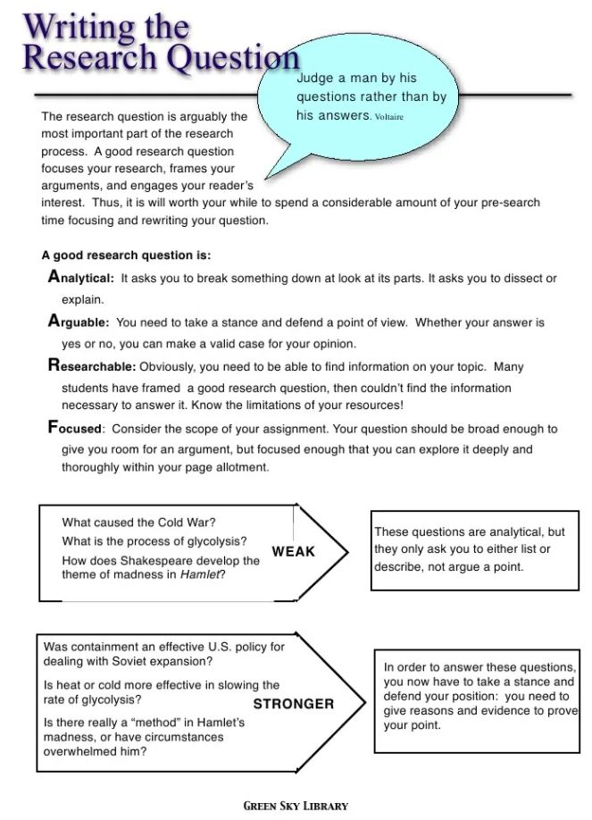

How to **write a research objectives**:

* A research objective must be achievable, i.e., it must be framed keeping in mind the available time, infrastructure required for research, and other resources.
* Before forming a research objective, you should read about all the developments in your area of research and find gaps in knowledge that need to be addressed. Readings will help you come up with suitable objectives for your research study.

Outcomes are classified as primary and secondary. It is advisable to have only one primary objective while secondary objectives can be multiple (usually not exceeding five). This paper describes a cascade approach starting from framing the research question and then deciding on the outcomes and study objectives.

**8. Methods/Methodology**

It is a detailed plan of how the objectives mentioned in the previous section will be achieved.

The **methods section** of your research proposal **should answer the following** questions:

* What is your study design and why did you choose it?
* Is the study qualitative or quantitative?
* What are the methods you will use to collect data?
* Who will be the participants of your study?
* What procedures/activities will the study involve?
* How long will the experiments/study take to get completed?

Tips for **writing a strong methodology:**

* Focus on your objectives and research questions
* Cite relevant sources
* Write for your audience
* Discuss obstacles

Describe the expected outcomes of the research

* Who will benefit from the study?
* Is the research responding to a new trend?
* Will the research fill a gap in knowledge?
* Answer research questions
* Reject/confirm hypotheses
* Recommendations will be made to encourage future research into problems that the research could not address

[*The dictatorship of the problem: Choosing research methods*](https://journals.sagepub.com/doi/pdf/10.4256/mio.2008.0006)

[*The methods chapter*](https://www.sagepub.com/sites/default/files/upm-binaries/14649_Chapter5.pdf)

[*Describe the research methods that will be used*](https://www.scribbr.com/category/methodology/#:~:text=The%20research%20methods%20you%20use%20depend%20on%20the,large%20amount%20of%20readily-available%20data%2C%20use%20secondary%20data.)

[*Selecting-and-Justifying-Your-Research-Design*](http://amandaszapkiw.com/artifacts/resources/tutorials/research-process/Step-4-Selecting-and-Justifying-Your-Research-Design.pdf)

[*Justify your methodological choice(s)*](http://amandaszapkiw.com/artifacts/resources/tutorials/research-process/Step-4-Selecting-and-Justifying-Your-Research-Design.pdf)

[*Describe the population of interest*](https://www.surveymonkey.com/market-research/resources/how-to-identify-population-of-interest/)

[*Describe the sampling approach*](https://www.questionpro.com/blog/types-of-sampling-for-social-research/#:~:text=Sampling%20definition%3A%20Sampling%20is%20a%20technique%20of%20selecting,them%20and%20estimate%20characteristics%20of%20the%20whole%20population.)

[*Describe the measuring instrument(s) that would be used*](https://nairaproject.com/blog/measurement-instrument.html#:~:text=Measurement%20instrument%20refers%20to%20various%20methods%20through%20which,researchers%20obtain%20from%20the%20participant%20of%20the%20study.)

[*Describe the data collection approach*](https://www.scribbr.com/methodology/data-collection/)

[*Describe the data analysis approach*](https://www.simplilearn.com/data-analysis-methods-process-types-article#:~:text=Data%20analysis%20is%20the%20process%20of%20cleaning%2C%20changing%2C,often%20presented%20in%20charts%2C%20images%2C%20tables%2C%20and%20graphs.)

**9. References**

It is the list all the sources that you have used in your project, so readers can easily find what you have cited.

* This is the list of all references cited in the research paper.
* The pattern of writing the references depends upon the kind of journal in which we are going to publish.
* References consulted must clearly indicate that the most relevant sources have been consulted.
* The researchers should follow the TUT prescribed format to construct a list of references.

**PROPOSAL DRAFT**

A piece of writing that is not yet in its finished form

[**A sample proposal with comments**](https://www.uh.edu/~lsong5/documents/A%20sample%20proposal%20with%20comment.pdf)

[**Annotated sample proposa**](https://my.uq.edu.au/files/10720/sample-annotated-research-proposal.pdf)**l**

**PORPOSAL REJECTIONS**

* What **causes proposal rejection**?

Students make mistakes when writing a research proposal, the research proposal will be rejected when:

* **The research topic is too broad or poorly articulated.**

One of the most common issues we see in dissertation and thesis proposals is that the research topic is simply too broad. In other words, the focus of the research is not ring-fenced tightly enough (or just not defined clearly enough), resulting in a proposal that has an unclear direction or attempts to take on too much.

* **The research aims, objectives and questions don’t align.**

An issue that we see with weaker research proposals is misalignment between the research aims and objectives, as well as with the research questions. Sometimes all three are misaligned, and sometimes there’s only one misfit. Whatever the case, it’s a problem that can lead to proposal rejection, as these three elements need to link together tightly.

* **The research topic is not well justified.**

How do we **justify a research**?

For a research topic to be well justified, you need to demonstrate both originality and importance.

**Originality** means that your proposed research is novel, or at least that its novel within its context (for example, within a specific country or industry). **Importance** is the second factor. Just because a topic is unique doesn’t mean it’s important. You need to be able to explain what the benefits of undertaking your proposed research would be. Who would benefit? How would they benefit? How could the newly developed knowledge be used in the world, whether in academia or industry?

* **The study has a weak theoretical foundation**

Your research needs to fill a clear gap in the literature – something that hasn’t been adequately researched, or that lacks research in a specific context. To convince your university that your topic will fill a gap in the research, your proposal needs to have a **strong theoretical foundation**. In other words, you need to show that you’ve done the necessary reading and are familiar with the existing research. To do this, you need to provide an integrated summary of the existing research and highlight (very clearly) the **theoretical gap** that exists.

* **The research design is not articulated well enough or is just impractical**

In this case students will have a clear design worked out in their mind but they haven’t put their plan to paper. At a minimum, you should provide detail regarding the following:

* + **Research philosophy** – the set of beliefs your research is based on (positivism, interpretivism, pragmatism)
  + **Research approach**– the broader method you’ll use (inductive, deductive, qualitative and quantitative)
  + **Research strategy** – how you’ll conduct the research (e.g., experimental, action, case study, etc.)
  + **Time horizon** – the number of points in time at which you’ll collect your data (e.g. cross-sectional or longitudinal)
  + **Techniques and procedures** – your intended data collection methods, data analysis techniques, sampling strategies, etc.
* **Poor writing and sloppy presentation**

The main issues here are:

* + **Directionless** or scattered writing – for example, writing that jumps from one point to another with poor flow and connectivity, disjointed points, etc.
  + **Poor argument** formation – for example, a lack of premises and conclusions, disconnected conclusions and poor reasoning.
  + **Inappropriate language** – for example, using a very informal or casual tone, slang, etc.).
  + **Grammar and spelling issues**, as well as inconsistent use of UK/US English.
  + **Referencing issues** – for example, a lack of references or incorrectly formatted references.
  + **Table and figure captions** – for example, a lack of captions, citations, figure and table numbers, etc.
  + **Low-quality visuals and diagrams**.
* **Poor project planning and risk management.**

Student are recommended to draw a Gantt chart detailing each major task involved in the dissertation writing process. They are also recommended to include the risk management plan (e.g. risk register) listing all the potential risks you foresee, as well as your mitigation and response actions, should they occur. Demonstrate that you have thought your research through and have a clear plan of action. Of course, as with your research design, plans can change and that’s okay. However, you still need to have an initial plan, and that plan needs to be realistic and manageable, or you’ll risk your proposal getting rejected.

* **Not following the university’s specific criteria.**

You need to pay very close attention to whatever institution-specific criteria your university has set out. Typically, your university will provide some sort of brief or guidance document to direct your proposal efforts, so be sure to study this document thoroughly and ask the faculty for clarity if you’re uncertain about anything. Some universities provide students with assessment criteria matrix, students need to study it and make sure that your research proposal tightly aligns with the assessment criteria.

[***Why funding proposals are rejected***](https://orsp.umich.edu/why-proposals-are-rejected)